Arabic abusive text analysis using logistic regression

Nadine Mohamed-205010, Alaa Badawy-205047, Ali Ayman-205049

Natural Language Processing | Dr. Esraa

Egyptian Russian University

**Abstract**

Social media is a popular and practical way for individuals to interact with one another and share their thoughts, feelings, and opinions. As more people communicate online, more cases of online abuse and cyberbullying also occur. The negative consequences of internet harassment and aggressive behavior are disturbing people more and more every day. To ensure social media usage is secure, it is necessary to control those who often participate in abusive behavior, such as cyberbullying. The technique of classifying statements into a specified sequence in text categorization is known as natural language processing (NLP). For this work, 3353 Arab textual statements from the " huggingface " dataset [1] were analyzed using natural language processing to identify abusive messages with an accuracy of 74%.

**1. Introduction**

Over the past few decades, social networks have grown in size and importance. People may now conveniently communicate and discuss ideas, opinions, and sentiments in their native tongues and cultures thanks to social media. At the same time as internet communication is expanding, social abuse is becoming more widespread. We might avoid issues like bullying and abuse by using a more effective and precise text categorization approach based on natural language processing (NLP).

**2. Research Methodology**

In order to efficiently identify abusive texts in Arabic, we employ machine learning technique (logistic regression), which is described in this section. Figure 1 shows how the process occurs.

**3. Dataset**

We only used data that was accessible from huggingface [1], where all of the data samples were given in Arabic.

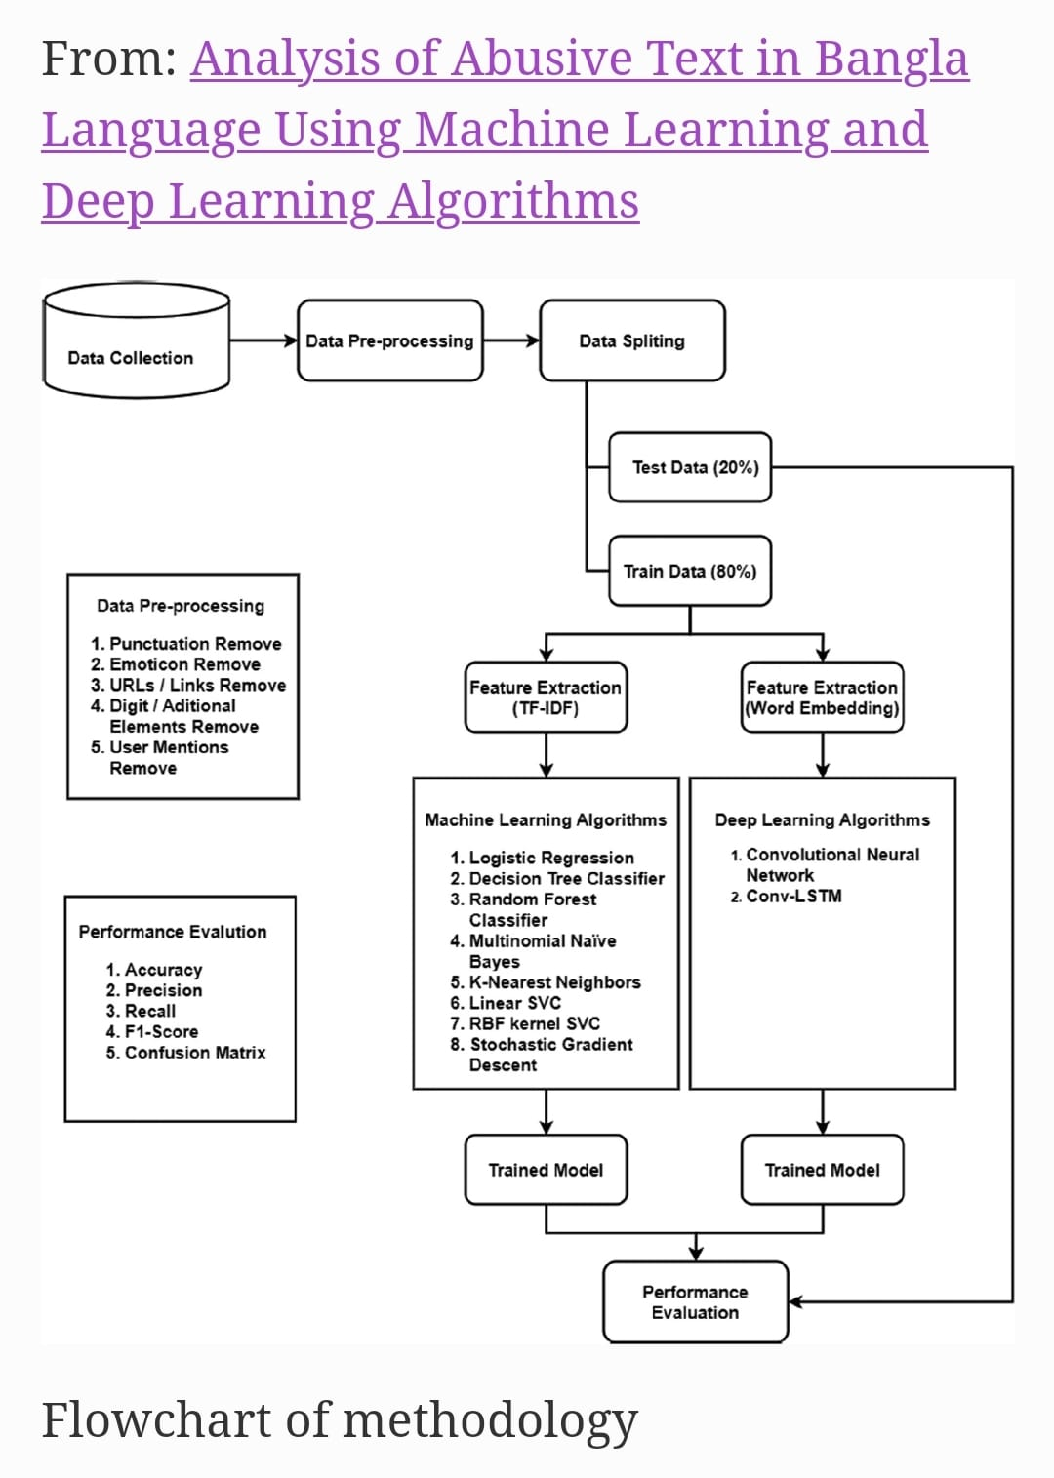

Figure 1

**4. code**

4.0 Importing needed liberaries

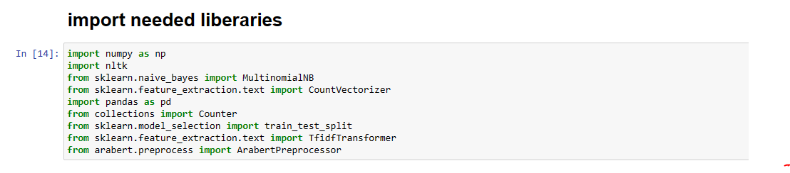

4.1 Importing Dataset

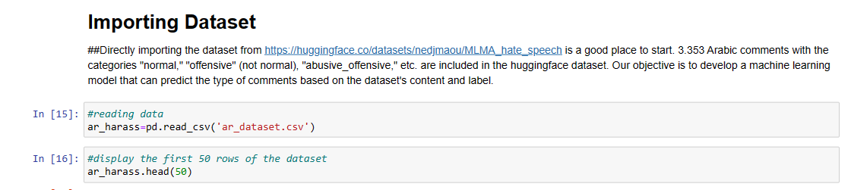

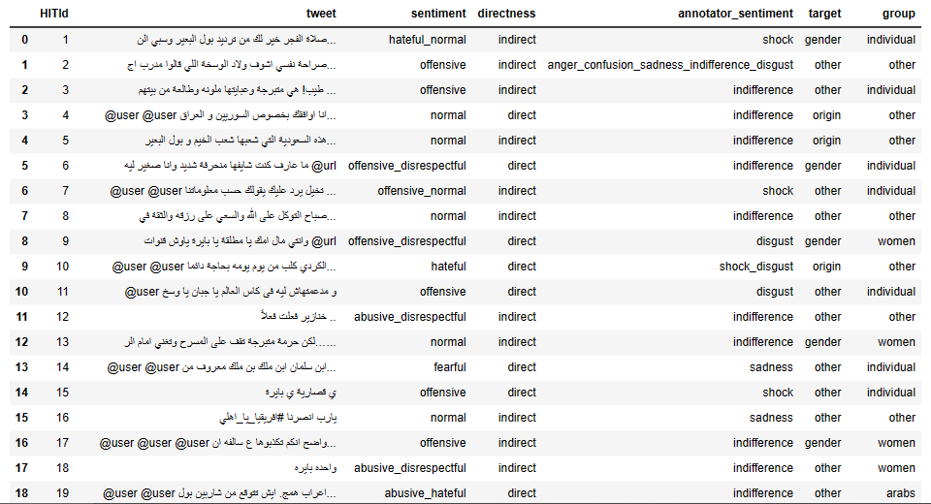

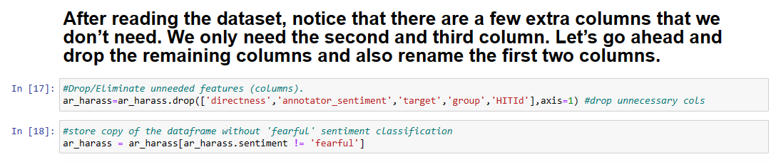

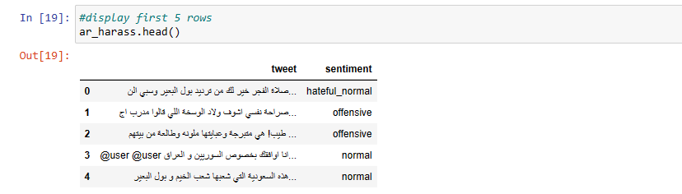

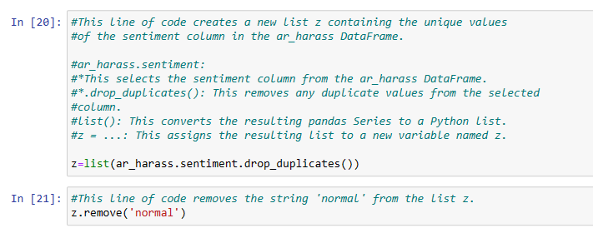

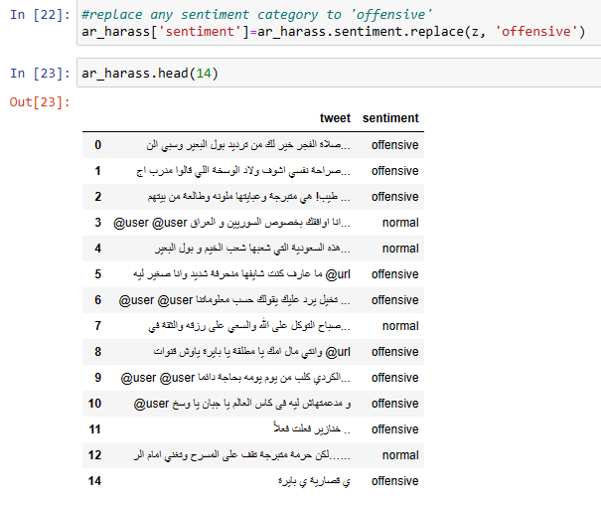

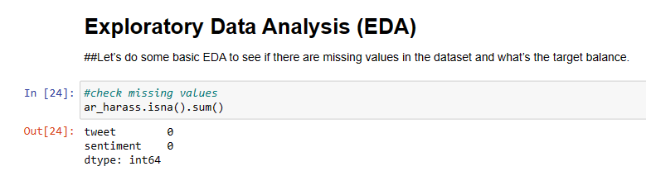

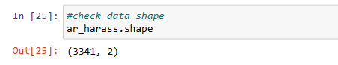

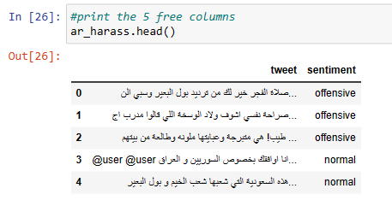

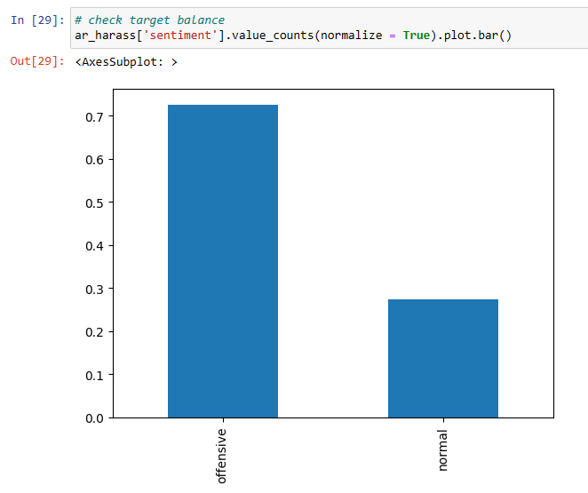

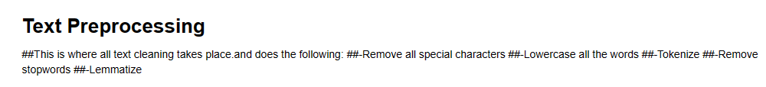

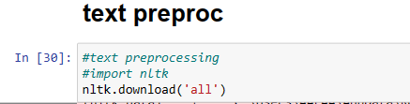

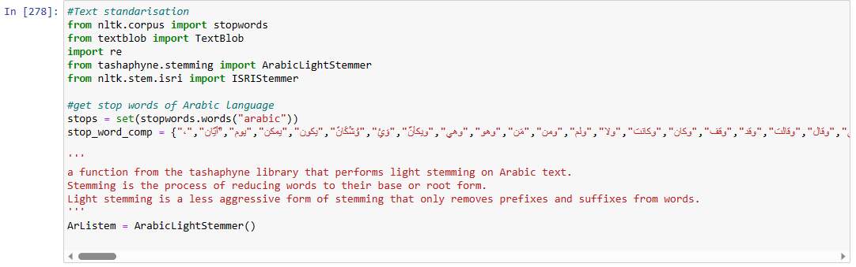

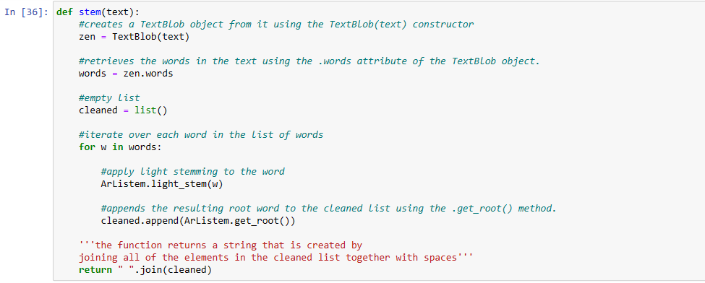

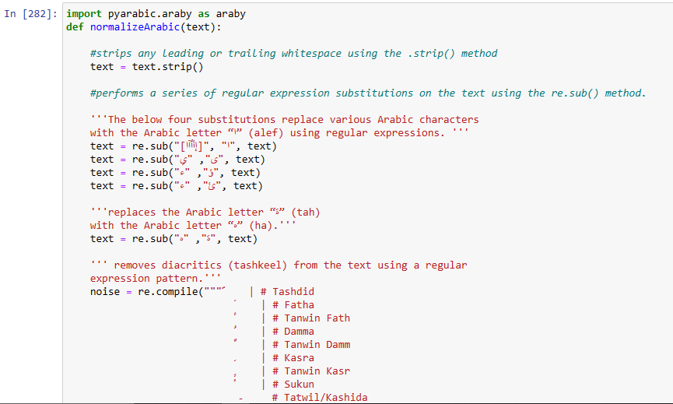

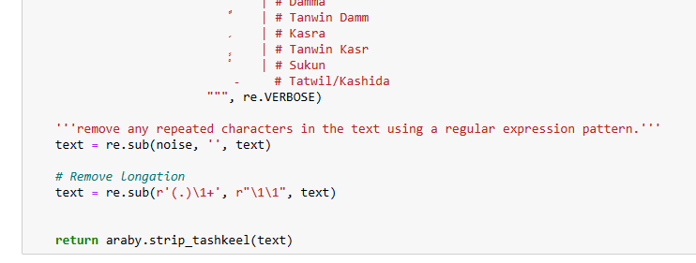

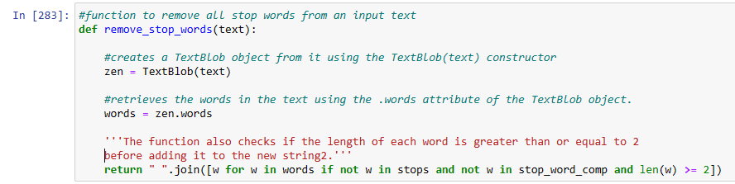

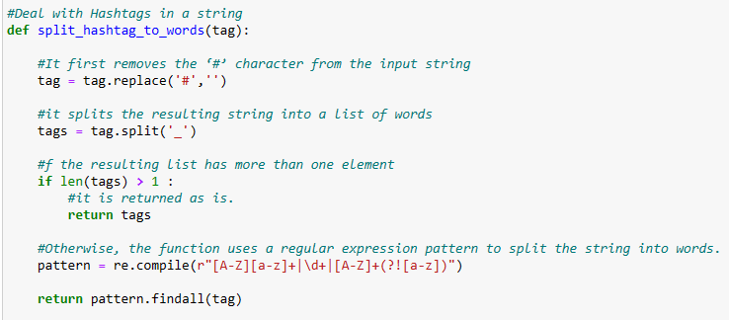

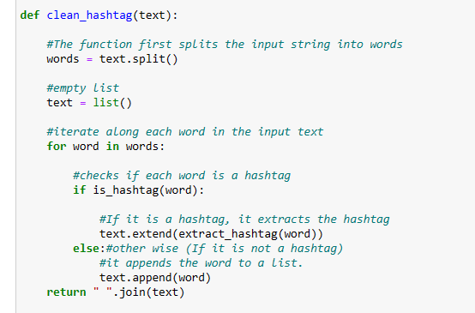

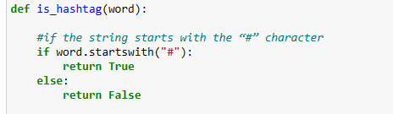

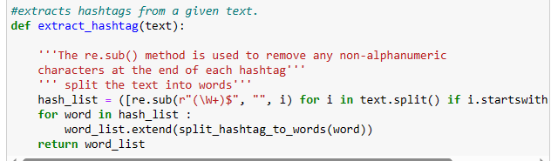

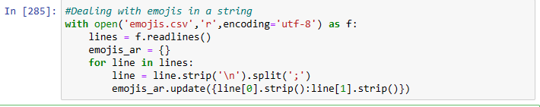

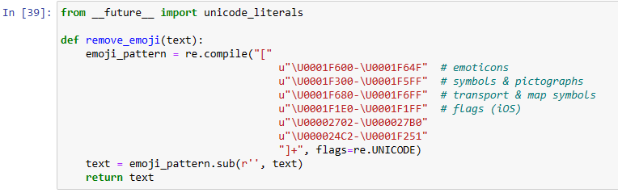

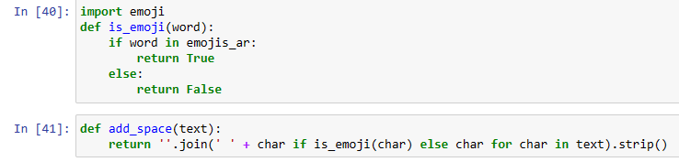

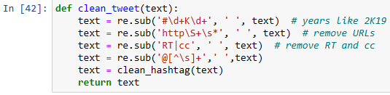

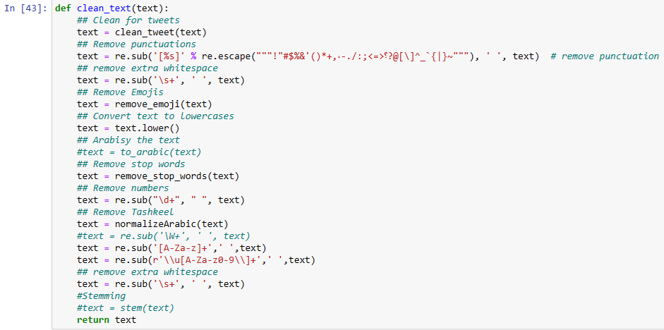



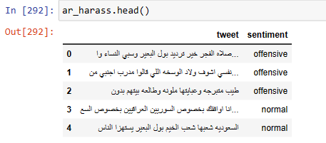

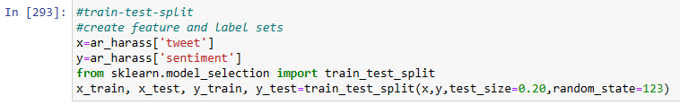





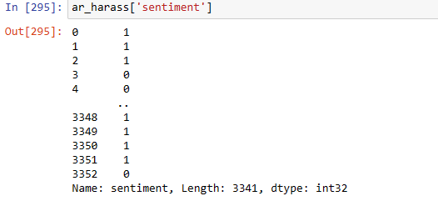

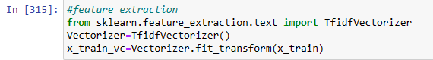

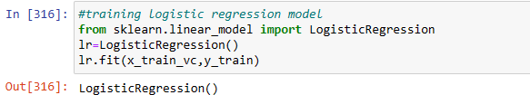

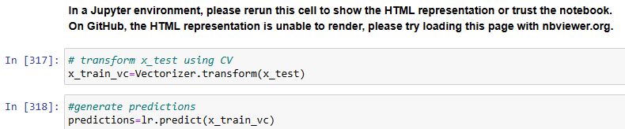

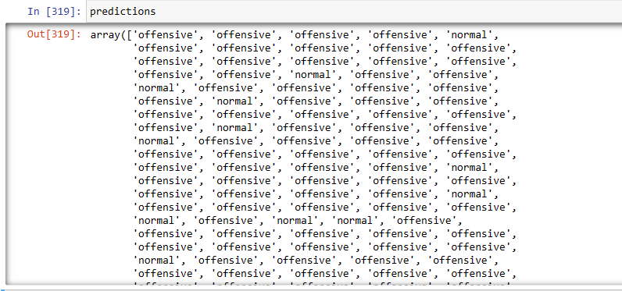

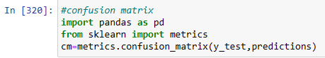

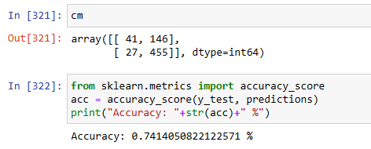

**Refrences**

1. <https://huggingface.co/datasets/nedjmaou/MLMA_hate_speech>